Mulholland, Seamus (photo from PerthLive website)
Anthea Gardner lost her husband Seamus, father Peter and brother Brett in a boating accident.
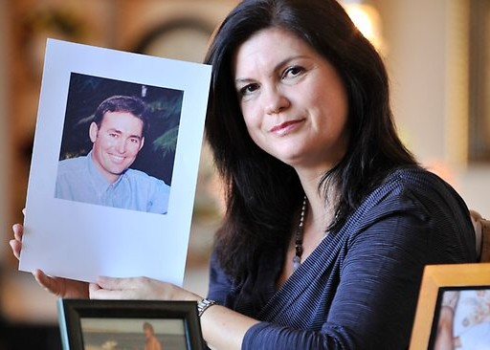
Headstone from Dunsborough cemetery:
MULHOLLAND , Seamus. 12 Aug 1964 - 31 Dec 1998. Husband of Anthea, son of Anthony and Beverley.

Seamus was an economist. He worked with George Malajczuk and Hamish Crawford at Crawley in the late 1980s. Was Manager of Plantations Group at Como in 1998.

